**SQL**

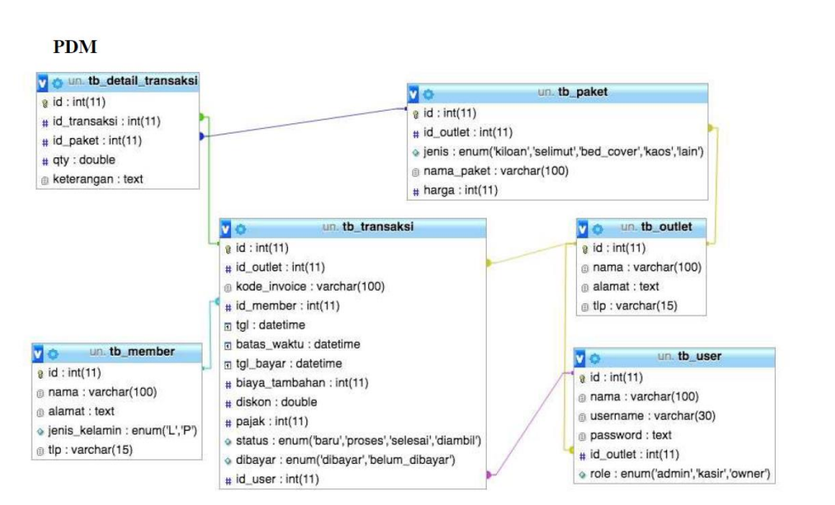

1. Buatlah basis data dengan nama laundry_db !

|  |
| --- |
| CREATE DATABASE `laundry_db` |





1. Buatlah semua tabel yang dibutuhkan sesuai rancangan !

Member

|  |
| --- |
| CREATE TABLE `tb_member` (  CREATE TABLE `tb_member` (  `id` int(11) NOT NULL AUTO_INCREMENT,  `nama` varchar(100) NOT NULL,  `alamat` text,  `jenis_kelamin` enum('L','P') DEFAULT NULL,  `tlp` varchar(15) DEFAULT NULL,  `created_at` timestamp NULL DEFAULT CURRENT_TIMESTAMP,  `updated_at` timestamp NOT NULL DEFAULT CURRENT_TIMESTAMP ON UPDATE CURRENT_TIMESTAMP,  PRIMARY KEY (`id`)  ); |

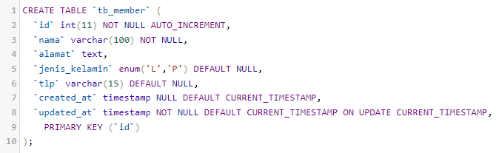

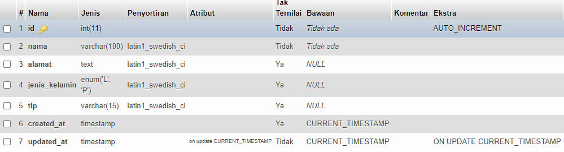

Outlet

|  |
| --- |
| CREATE TABLE `tb_outlet` (  `id` int(11) NOT NULL AUTO_INCREMENT,  `nama` varchar(100) DEFAULT NULL,  `alamat` text,  `tlp` varchar(15) DEFAULT NULL,  `created_at` timestamp NULL DEFAULT CURRENT_TIMESTAMP,  `updated_at` timestamp NOT NULL DEFAULT CURRENT_TIMESTAMP ON UPDATE CURRENT_TIMESTAMP,  PRIMARY KEY (`id`)  ); |

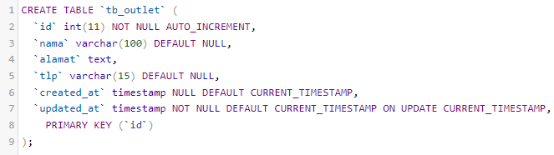

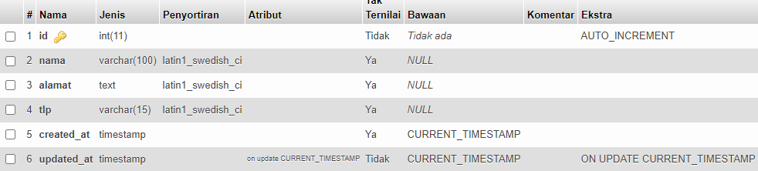

Paket

|  |
| --- |
| CREATE TABLE `tb_paket` (  `id` int(11) NOT NULL AUTO_INCREMENT,  `id_outlet` int(11) DEFAULT NULL,  `jenis` enum('kiloan','selimut','ned_cover','kaos','lain') DEFAULT NULL,  `nama_paket` varchar(100) DEFAULT NULL,  `harga` int(11) DEFAULT NULL,  `created_at` timestamp NULL DEFAULT CURRENT_TIMESTAMP,  `updated_at` timestamp NOT NULL DEFAULT CURRENT_TIMESTAMP ON UPDATE CURRENT_TIMESTAMP,  PRIMARY KEY (`id`)  ); |

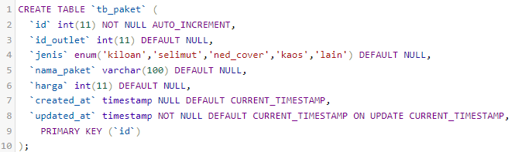

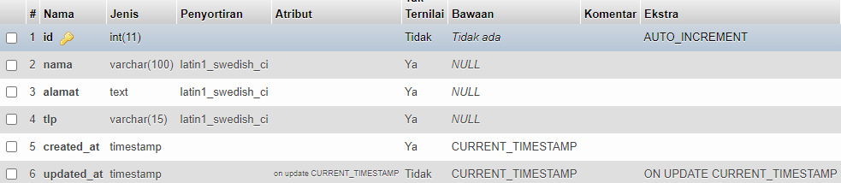

User

|  |
| --- |
| CREATE TABLE `tb_user` (  `id` int(11) NOT NULL AUTO_INCREMENT,  `nama` varchar(100) DEFAULT NULL,  `usernam` varchar(30) DEFAULT NULL,  `password` text,  `id_outlet` int(11) DEFAULT NULL,  `created_at` timestamp NULL DEFAULT CURRENT_TIMESTAMP,  `updated_at` timestamp NOT NULL DEFAULT CURRENT_TIMESTAMP ON UPDATE CURRENT_TIMESTAMP,  PRIMARY KEY (`id`)  ); |

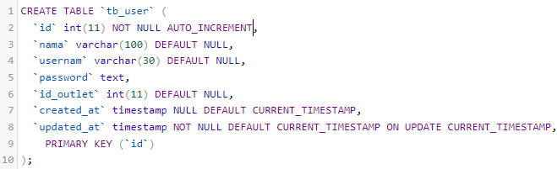

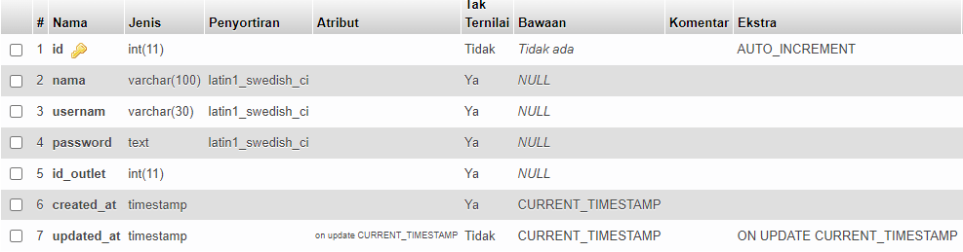

Detail Transaksi

|  |
| --- |
| CREATE TABLE `tb_detail_transaksi` (  CREATE TABLE `tb_detail_transaksi` (  `id` int(11) NOT NULL AUTO_INCREMENT,  `id_transaksi` int(11) DEFAULT NULL,  `id_paket` int(11) DEFAULT NULL,  `qty` double DEFAULT NULL,  `created_at` timestamp NULL DEFAULT CURRENT_TIMESTAMP,  `updated_at` timestamp NOT NULL DEFAULT CURRENT_TIMESTAMP ON UPDATE CURRENT_TIMESTAMP,  PRIMARY KEY (`id`)  ); |

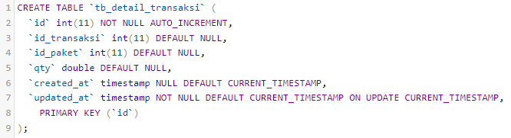

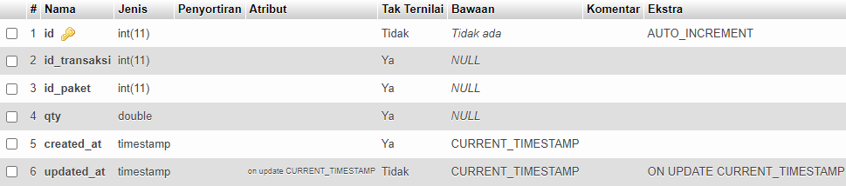

Transaksi

|  |
| --- |
| CREATE TABLE `tb_transaksi` (  `id` int(11) NOT NULL AUTO_INCREMENT,  `id_outlet` int(11) DEFAULT NULL,  `kode_invoice` varchar(100) DEFAULT NULL,  `id_member` int(11) DEFAULT NULL,  `tgl` datetime DEFAULT NULL,  `tgl_bayar` datetime DEFAULT NULL,  `biaya_tambahan` int(11) DEFAULT NULL,  `diskon` double DEFAULT NULL,  `pajak` int(11) DEFAULT NULL,  `status` enum('baru','proses','selesai','diambil') DEFAULT NULL,  `dibayar` enum('dibayar','belum_bayar') DEFAULT NULL,  `id_user` int(11) DEFAULT NULL,  `created_at` timestamp NULL DEFAULT CURRENT_TIMESTAMP,  `updated_at` timestamp NOT NULL DEFAULT CURRENT_TIMESTAMP ON UPDATE CURRENT_TIMESTAMP,  PRIMARY KEY (`id`)  ); |

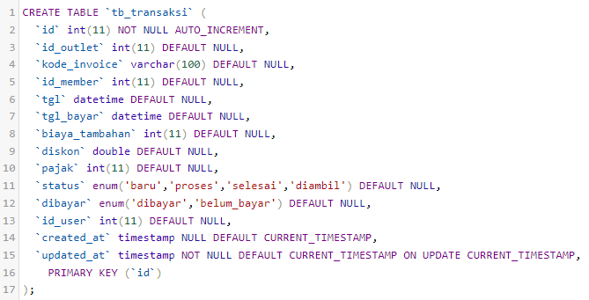

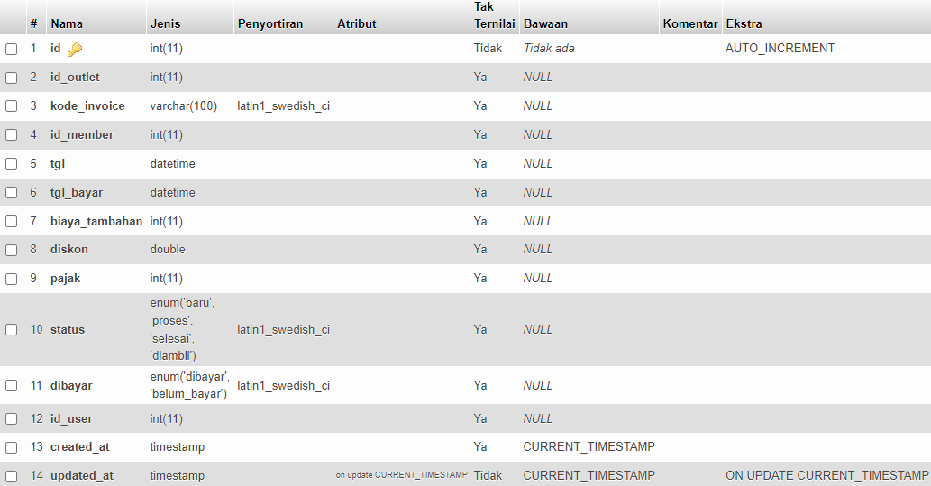

1. Lakukan penambahan data pada semua tabel master minimal 3 data tiap tabel !

Member

|  |
| --- |
| INSERT INTO `tb_member` (`id`, `nama`, `alamat`, `jenis_kelamin`, `tlp`, `created_at`, `updated_at`) VALUES  ('1', 'Bara', 'Cianjur', 'L', '0882', CURRENT_TIMESTAMP, CURRENT_TIMESTAMP),  ('2', 'Ranu', 'Karangtengah', 'L', '0883', CURRENT_TIMESTAMP, CURRENT_TIMESTAMP),  ('3', 'Raihana', 'Bandung', 'P', '0884', CURRENT_TIMESTAMP, CURRENT_TIMESTAMP); |

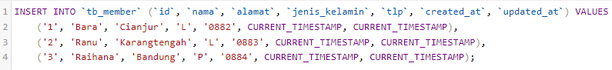

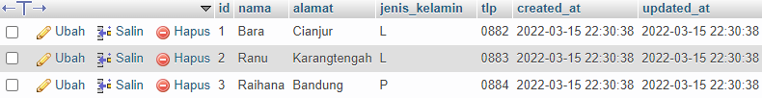

Outlet

|  |
| --- |
| INSERT INTO `tb_outlet` (`id`, `nama`, `alamat`, `tlp`, `created_at`, `updated_at`) VALUES  ('1', 'Balady', 'Karangtengah', '0882', CURRENT_TIMESTAMP, CURRENT_TIMESTAMP),  ('2', 'Laund', 'Cianjur', '0883', CURRENT_TIMESTAMP, CURRENT_TIMESTAMP),  ('3', 'BaLaund', 'Bandung', '0884', CURRENT_TIMESTAMP, CURRENT_TIMESTAMP); |

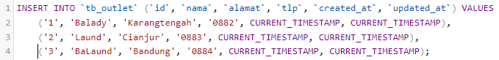

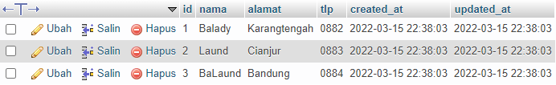

Paket

|  |
| --- |
| INSERT INTO `tb_paket` (`id`, `id_outlet`, `jenis`, `nama_paket`, `harga`, `created_at`, `updated_at`) VALUES  ('1', '1', 'kiloan', 'PKi', '20000', CURRENT_TIMESTAMP, CURRENT_TIMESTAMP),  ('2', '1', 'selimut', 'PSi', '25000', CURRENT_TIMESTAMP, CURRENT_TIMESTAMP),  ('3', '1', 'kaos', 'PKa', '23000', CURRENT_TIMESTAMP, CURRENT_TIMESTAMP); |

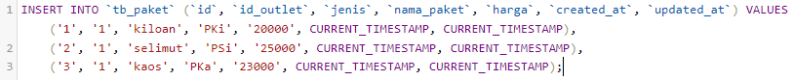

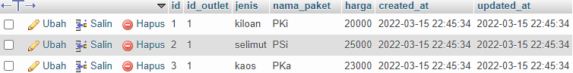

User

|  |
| --- |
| INSERT INTO `tb_user` (`id`, `nama`, `usernam`, `password`, `id_outlet`, `created_at`, `updated_at`) VALUES  ('1', 'Raihan', 'Raihan@gmail.com', '12345678', '1', CURRENT_TIMESTAMP, CURRENT_TIMESTAMP),  ('2', 'Bara', 'bara@gmail.com', '12345678', '1', CURRENT_TIMESTAMP, CURRENT_TIMESTAMP),  ('3', 'MRanu', 'mranu@gmail.com', '12345678', '1', CURRENT_TIMESTAMP, CURRENT_TIMESTAMP); |

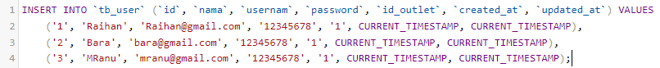

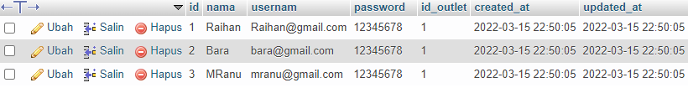

Transaksi

|  |
| --- |
| INSERT INTO `tb_transaksi` (`id`, `id_outlet`, `kode_invoice`, `id_member`, `tgl`, `tgl_bayar`, `biaya_tambahan`, `diskon`, `pajak`, `status`, `dibayar`, `id_user`, `created_at`, `updated_at`) VALUES  ('1', '1', 'KD001', '1', '2022-03-15 15:55:25.000000', '2022-03-15 15:55:25.000000', '1000', '1000', '10', 'baru', 'belum_bayar', '1', CURRENT_TIMESTAMP, CURRENT_TIMESTAMP),  ('2', '1', 'KD002', '1', '2022-03-15 15:55:25.000000', '2022-03-15 15:55:25.000000', '1000', '1000', '10', 'proses', 'dibayar', '1', CURRENT_TIMESTAMP, CURRENT_TIMESTAMP),  ('3', '1', 'KD003', '1', '2022-03-15 15:55:25.000000', '2022-03-15 15:55:25.000000', '1000', '1000', '10', 'selesai', 'dibayar', '1', CURRENT_TIMESTAMP, CURRENT_TIMESTAMP); |

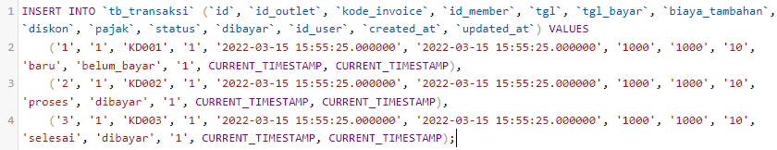



Detail Transaksi

|  |
| --- |
| INSERT INTO `tb_detail_transaksi` (`id`, `id_transaksi`, `id_paket`, `qty`, `created_at`, `updated_at`) VALUES  ('1', '1', '1', '2', CURRENT_TIMESTAMP, CURRENT_TIMESTAMP),  ('2', '1', '1', '3', CURRENT_TIMESTAMP, CURRENT_TIMESTAMP),  ('3', '1', '1', '4', CURRENT_TIMESTAMP, CURRENT_TIMESTAMP); |



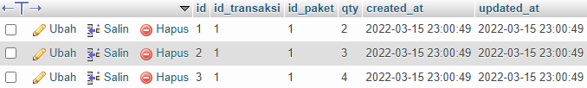

1. Lakukan perubahan data pada semua tabel master minimal 1 data tiap tabel

Member

|  |
| --- |
| UPDATE `tb_member` SET `nama` = 'Raihan', `jenis_kelamin` = 'L' WHERE `tb_member`.`id` = 3; |



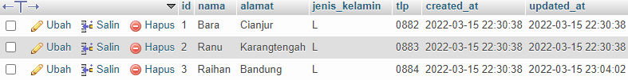

Outlet

|  |
| --- |
| UPDATE `tb_outlet` SET `nama` = 'BaLa' WHERE `tb_outlet`.`id` = 3; |



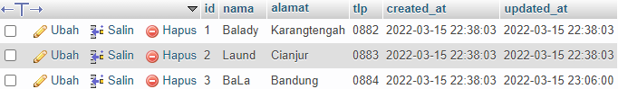

Paket

|  |
| --- |
| UPDATE `tb_paket` SET `jenis` = 'lain', `nama_paket` = 'PLa' WHERE `tb_paket`.`id` = 3; |



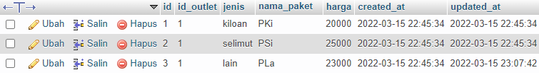

User

|  |
| --- |
| UPDATE `tb_user` SET `nama` = 'Ranu', `usernam` = 'ranu@gmail.com' WHERE `tb_user`.`id` = 3; |



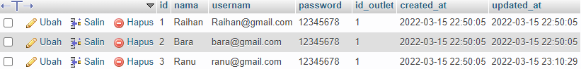

Transaksi

|  |
| --- |
| UPDATE `tb_transaksi` SET `biaya_tambahan` = '10000', `diskon` = '10000' WHERE `tb_transaksi`.`id` = 3; |





Detail Transaksi

|  |
| --- |
| UPDATE `tb_detail_transaksi` SET `qty` = '2' WHERE `tb_detail_transaksi`.`id` = 3; |



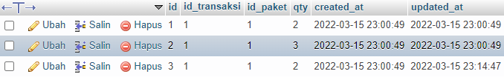

1. Lakukan penghapusan data pada semua tabel master minimal 1 data tiap tabel !

Member

|  |
| --- |
| DELETE FROM `tb_member` WHERE `tb_member`.`id` = 3 |





Outlet

|  |
| --- |
| DELETE FROM `tb_outlet` WHERE `tb_outlet`.`id` = 3 |



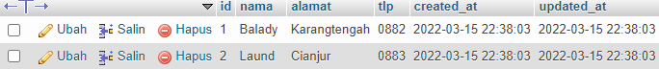

Paket

|  |
| --- |
| DELETE FROM `tb_paket` WHERE `tb_paket`.`id` = 3 |





User

|  |
| --- |
| DELETE FROM `tb_user` WHERE `tb_user`.`id` = 3 |





Transaksi

|  |
| --- |
| DELETE FROM `tb_transaksi` WHERE `tb_transaksi`.`id` = 3 |





Detail Transaksi

|  |
| --- |
| DELETE FROM `tb_detail_transaksi` WHERE `tb_detail_transaksi`.`id` = 3 |



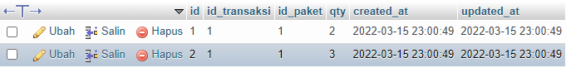

1. Buatlah instruksi SQL untuk menampilkan id, nama_paket, Jenis, harga pada table paket yang harganya dibawah 50000 !

|  |
| --- |
| SELECT `id`, `nama_paket`, `jenis`, `harga` FROM `tb_paket` WHERE `harga` <= 50000 |



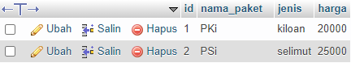

1. Buatlah instruksi SQL untuk menampilkan id, tgl, status (tabel Transaksi), nama, alamat (table member), nama_paket, jenis, harga (table Paket) dimana data transaksi tersebut memiliki status “DIAMBIL”!

|  |
| --- |
| SELECT t.id, t.tgl, t.status, m.nama, m.alamat, p.nama_paket, p.jenis, p.harga FROM  tb_detail_transaksi d INNER JOIN tb_paket p on d.id_paket = p.id  INNER JOIN tb_transaksi t on d.id_transaksi = t.id  INNER JOIN tb_member m on m.id = t.id_member  WHERE t.status = 'diambil'; |

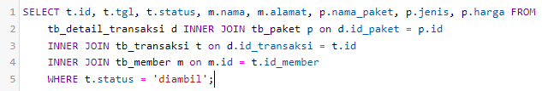



1. Buatlah Stored Procedure untuk menampilkan id, tgl, status (tabel Transaksi), nama, alamat (table member), nama_paket, jenis, harga (table Paket) dimana data transaksi tersebut memiliki status “PROSES”!

|  |
| --- |
| CREATE PROCEDURE `show_paket_proses` ()  BEGIN  SELECT t.id, t.tgl, t.status, m.nama, m.alamat, p.nama_paket, p.jenis, p.harga FROM  tb_detail_transaksi d INNER JOIN tb_paket p on d.id_paket = p.id  INNER JOIN tb_transaksi t on d.id_transaksi = t.id  INNER JOIN tb_member m on m.id = t.id_member  WHERE t.status = 'proses';  END // |

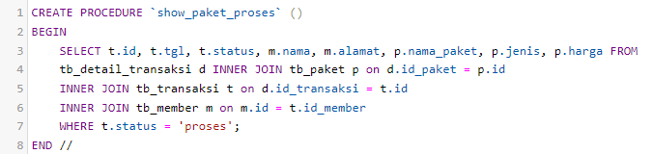

|  |
| --- |
| CALL PROCEDURE `show_paket_proses`; |





1. Buatlah function untuk menghasilkan total transaksi dengan parameter adalah id_transaksi, dimana alur prosesna adalah dengan menjumlahkan harga per paket di kali dengan jumlah pakaian yang di ambil dari detail transaksi!

|  |
| --- |
| DELIMITER //  CREATE FUNCTION `GET_TOTAL_TRANSAKSI`(id_transaksi INT)  RETURNS DOUBLE  DETERMINISTIC  BEGIN  DECLARE total DOUBLE;  SELECT SUM(d.qty * p.harga) INTO total FROM tb_transaksi t  INNER JOIN tb_detail_transaksi d ON d.id_transaksi = t.id  INNER JOIN tb_paket p ON d.id_paket = p.id  WHERE t.id = id_transaksi;  RETURN total;  END //  DELIMITER ; |

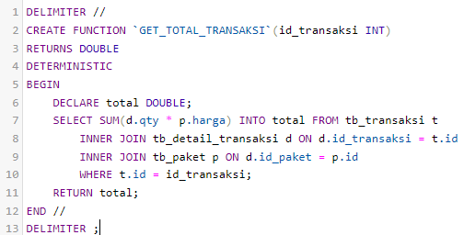

|  |
| --- |
| SELECT `GET_TOTAL_TRANSAKSI`(1); |





1. Buatlah table logging dengan field aksi typedata varchar(20), waktu typedata datetime

|  |
| --- |
| CREATE TABLE `logging` (  `aksi` varchar(20) NOT NULL,  `waktu` datetime NOT NULL  ); |

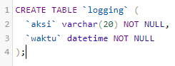

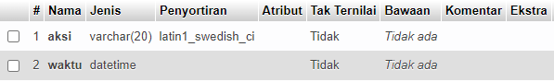

1. Buatlah 3 trigger untuk menginput pada table logging apabila ada kejadian insert, update dan delete pada table paket

|  |
| --- |
| DELIMITER //  CREATE TRIGGER `LOG_INSERT_PAKET` AFTER INSERT ON `tb_paket` FOR EACH ROW BEGIN  INSERT INTO logging VALUES ('INSERT PAKET', NOW());  END //  DELIMITER ; |

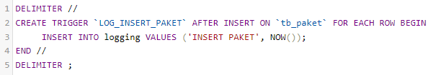

|  |
| --- |
| DELIMITER //  CREATE TRIGGER `LOG_UPDATE_PAKET` AFTER UPDATE ON `tb_paket` FOR EACH ROW BEGIN  INSERT INTO logging VALUES ('UPDATE PAKET', NOW());  END //  DELIMITER ; |

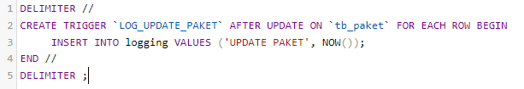

|  |
| --- |
| DELIMITER //  CREATE TRIGGER `LOG_DELETE_PAKET` BEFORE DELETE ON `tb_paket` FOR EACH ROW BEGIN  INSERT INTO logging VALUES ('DELETE PAKET', NOW());  END //  DELIMITER ; |

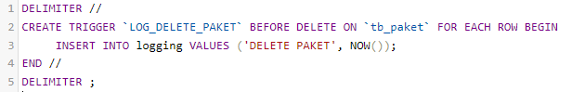

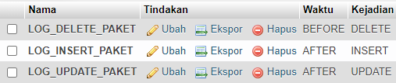

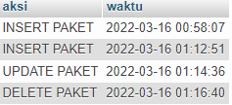

1. Buatlah view dengan nama v_transaksi untuk menampilkan id, tgl, status (tabel Transaksi), nama, alamat (table member), nama_paket, jenis, harga (table Paket) dimana data transaksi tersebut memiliki status “BARU”!

|  |
| --- |
| CREATE VIEW V_TRANSAKSI AS SELECT t.id, t.tgl, t.status, m.nama, m.alamat, p.nama_paket, p.jenis, p.harga  FROM tb_detail_transaksi d INNER JOIN tb_paket p on d.id_paket = p.id  INNER JOIN tb_transaksi t on d.id_transaksi = t.id  INNER JOIN tb_member m on m.id = t.id_member  WHERE t.status = 'baru'; |

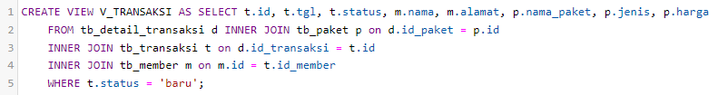

|  |
| --- |
| SELECT * FROM `v_transaksi` |





1. Buatlah perintah commit untuk aksi insert data pada tabel transaksi



|  |
| --- |
| START TRANSACTION;  INSERT INTO `tb_transaksi` (`id`, `id_outlet`, `kode_invoice`, `id_member`, `tgl`, `tgl_bayar`, `biaya_tambahan`, `diskon`, `pajak`, `status`, `dibayar`, `id_user`, `created_at`, `updated_at`) VALUES  ('3', '1', 'KD001', '1', '2022-03-15 15:55:25.000000', '2022-03-15 15:55:25.000000', '1000', '1000', '10', 'baru', 'belum_bayar', '1', CURRENT_TIMESTAMP, CURRENT_TIMESTAMP);  COMMIT; |

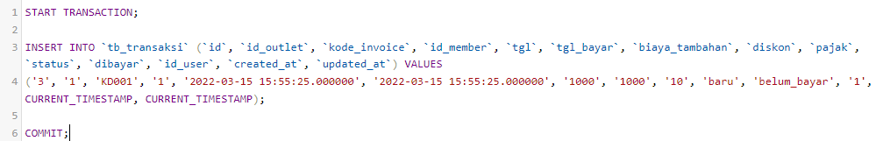

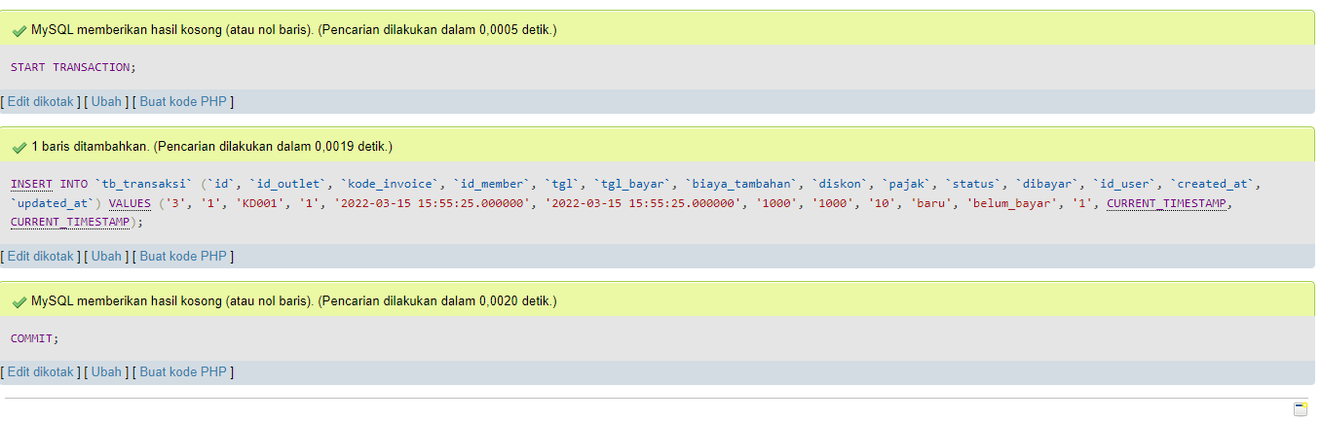

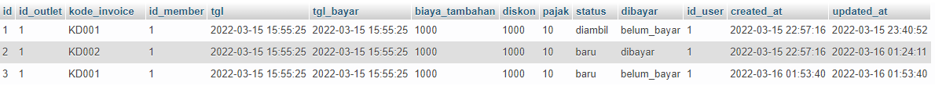

1. Buatlah perintah rollback untuk aksi insert pada tabel transaksi



|  |
| --- |
| START TRANSACTION;  INSERT INTO `tb_transaksi` (`id`, `id_outlet`, `kode_invoice`, `id_member`, `tgl`, `tgl_bayar`, `biaya_tambahan`, `diskon`, `pajak`, `status`, `dibayar`, `id_user`, `created_at`, `updated_at`) VALUES  ('4', '1', 'KD001', '1', '2022-03-15 15:55:25.000000', '2022-03-15 15:55:25.000000', '1000', '1000', '10', 'baru', 'belum_bayar', '1', CURRENT_TIMESTAMP, CURRENT_TIMESTAMP);  ROLLBACK; |

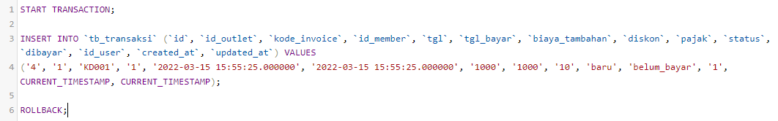

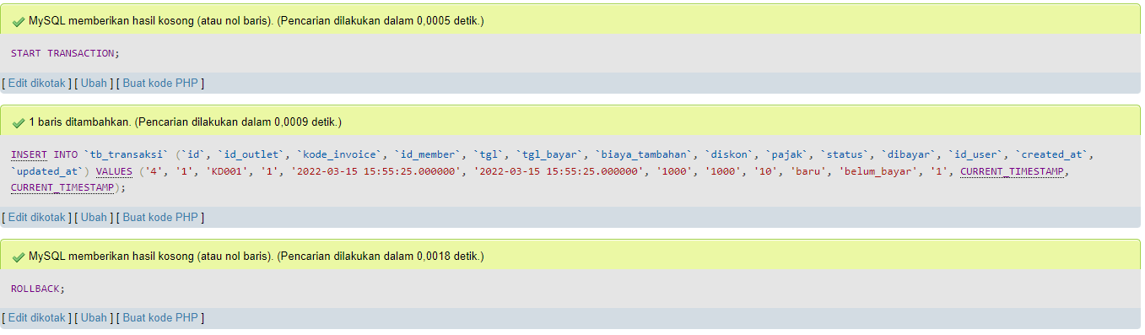



1. Buatlah user baru dengan nama ADMINISTRATOR dan password UJIKOM, berikan hakakses agar user dapat menggunakan fungsi select,insert,update,delete pada semua table di database laundry_db

|  |
| --- |
| CREATE USER ADMINISTRATOR IDENTIFIED BY ‘UJIKOM’;  GRANT SELECT, INSERT, UPDATE, DELETE ON laundry_db.* TO ADMINISTRATOR; |





1. Buatlah user baru dengan nama OPERATOR dan password UJIKOM, cabut hak akses agar user tidak dapat menggunakan fungsi select,insert,update,delete pada table outlet dan paket di database laundry_db

|  |
| --- |
| CREATE USER OPERATOR IDENTIFIED BY ‘UJIKOM’;  GRANT SELECT, INSERT, UPDATE, DELETE ON laundry_db.* TO OPERATOR; |

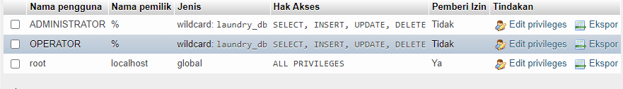

|  |
| --- |
| REVOKE SELECT, INSERT, UPDATE, DELETE ON laundry_db.tb_outlet TO OPERATOR;  REVOKE SELECT, INSERT, UPDATE, DELETE ON laundry_db.tb_member TO OPERATOR; |



1. Lakukan backup dan restore basis laundry_db menggunakan dbms

|  |
| --- |
| mysqldump -u root -p laundry_db > ./laundry_db.sql |



|  |
| --- |
| mysql -u root -p laundry_db2 < ./laundry_db.sql |



